ELEG 312 - Example Problems Chapter 8-2

**Example 8.2**

We wish to compare the values of *gm, Rin, Ro,* and *A*0 for a CS amplifier that is designed using an NMOS transistor with *L* = 0.4 m and *W* = 4 m and fabricated to a 0.25-m technology specified to have *nCox* = 267 A/V2 and *V’A* = 10 V/um,with those for a CE amplifier designed using a BJT fabricated in a process with ** = 100 and *VA* = 10 V. Assume that both devices are operating at a drain (collector) current of 100 A.

Common Source Amplifier

given:

$$I_{D}=100 μA$$

$$μ_{n}C_{ox}=267{μA}/{V^{2}}$$

$$\frac{W}{L}=\frac{4 μm}{0.4 μm}=10$$

Common Emitter Amplifier

given:

$$I_{C}=100 μA$$

$$β=100$$

$$V_{A}=10 V$$

**Problem 8.27** Find the intrinsic gain of an NMOS transistor fabricated in a process for which  = 400 μA/V2 and  = 10 V/μm. The transistor has a 0.5-μm channel length and is operated at *VOV* =0.2 V. If a 2-mA/V transconductance is required, what must *ID* and *W* be?

**Example 8.**

Consider the CMOS common-source amplifier in Fig. 8.16(a) for the case *VDD* = 3 V, *Vtn* = |*Vtp*| = 0.6 V, *nCox* = 200 A/V2, and *pCox* = 65 A/V2*.* For all transistors, *L* = 0.4 m and *W* = 4 m . Also, *VAn* = 20 V, |*VAp*| = 10 V, and *IREF* = 100 A . Find the small-signal voltage gain. Also, find the coordinates of the extremities of the amplifier region of the transfer characteristic- that is, points A and B.

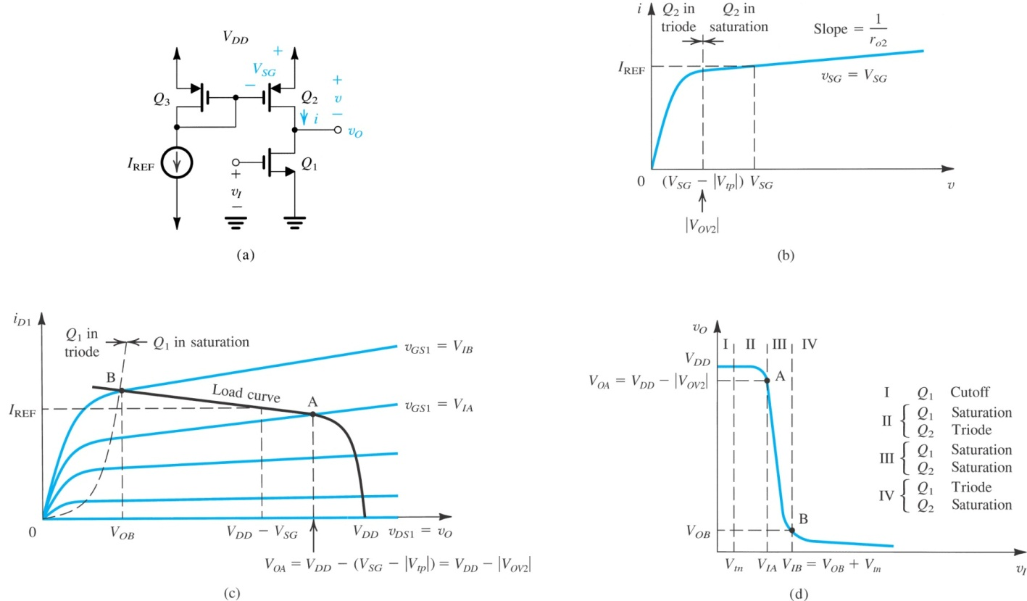given:

*VDD* = 3 V

*Vtn* = |*Vtp*| = 0.6 V

*nCox* = 200 A/V2

*pCox* = 65 A/V2

*L* = 0.4 m

*W* = 4 m

*VAn* = 20 V

|*VAp*| = 10 V

*IREF* = 100 A

